**Project Report**

**In partial fulfillment**

**of the requirement for the course of**

***“Computer Networks”***

**By**

**Zirwah Khalil | i220748**

**BSCS-C**

**Topology**

**VLSM**

**Public**

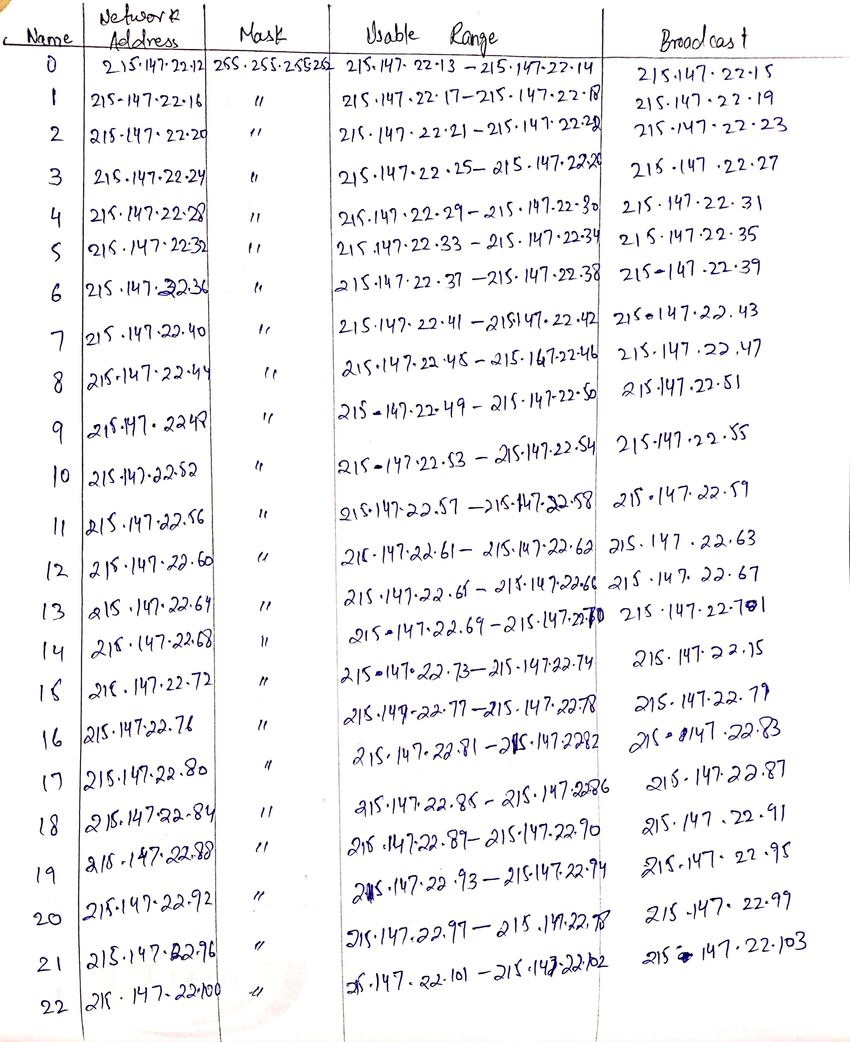

**Private**

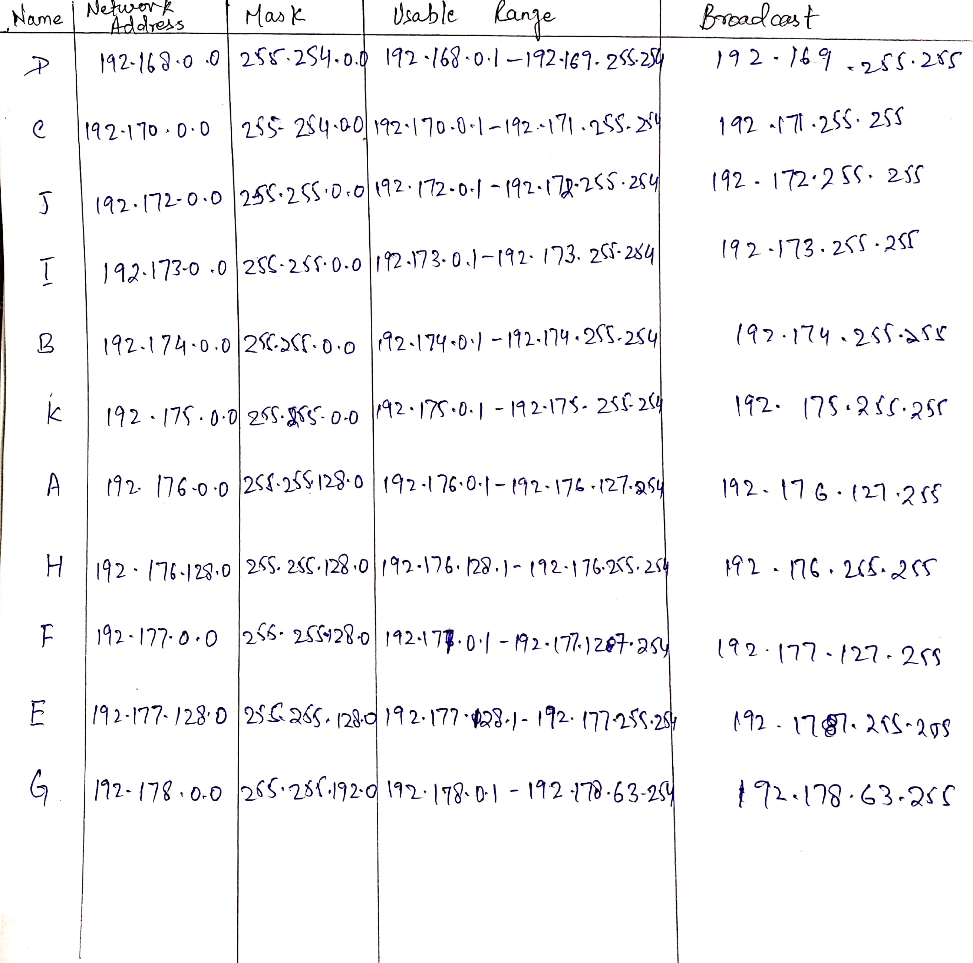

**Routing**

**RIP**

**Router 0  
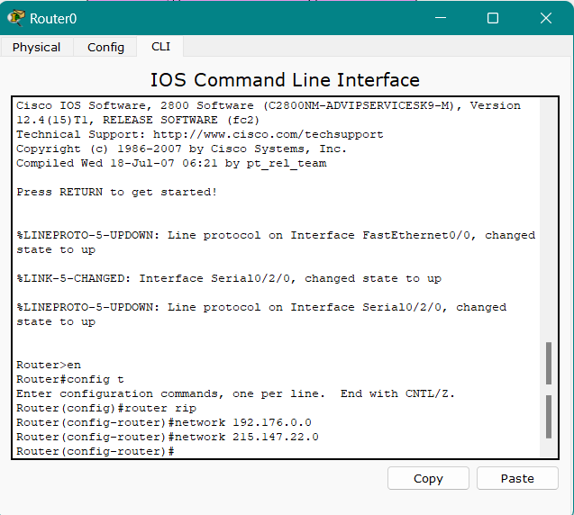**

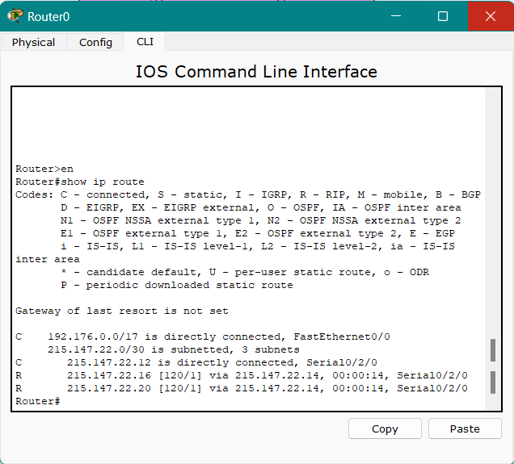

**Routing Table**

**Router 1**

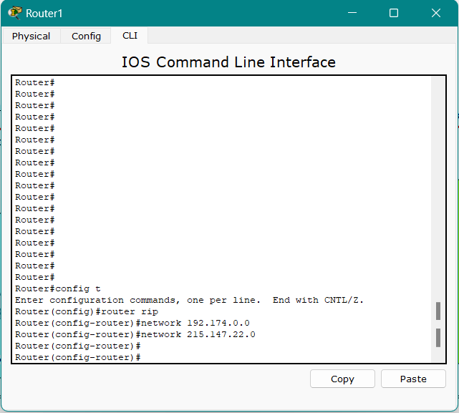

**Routing Table**

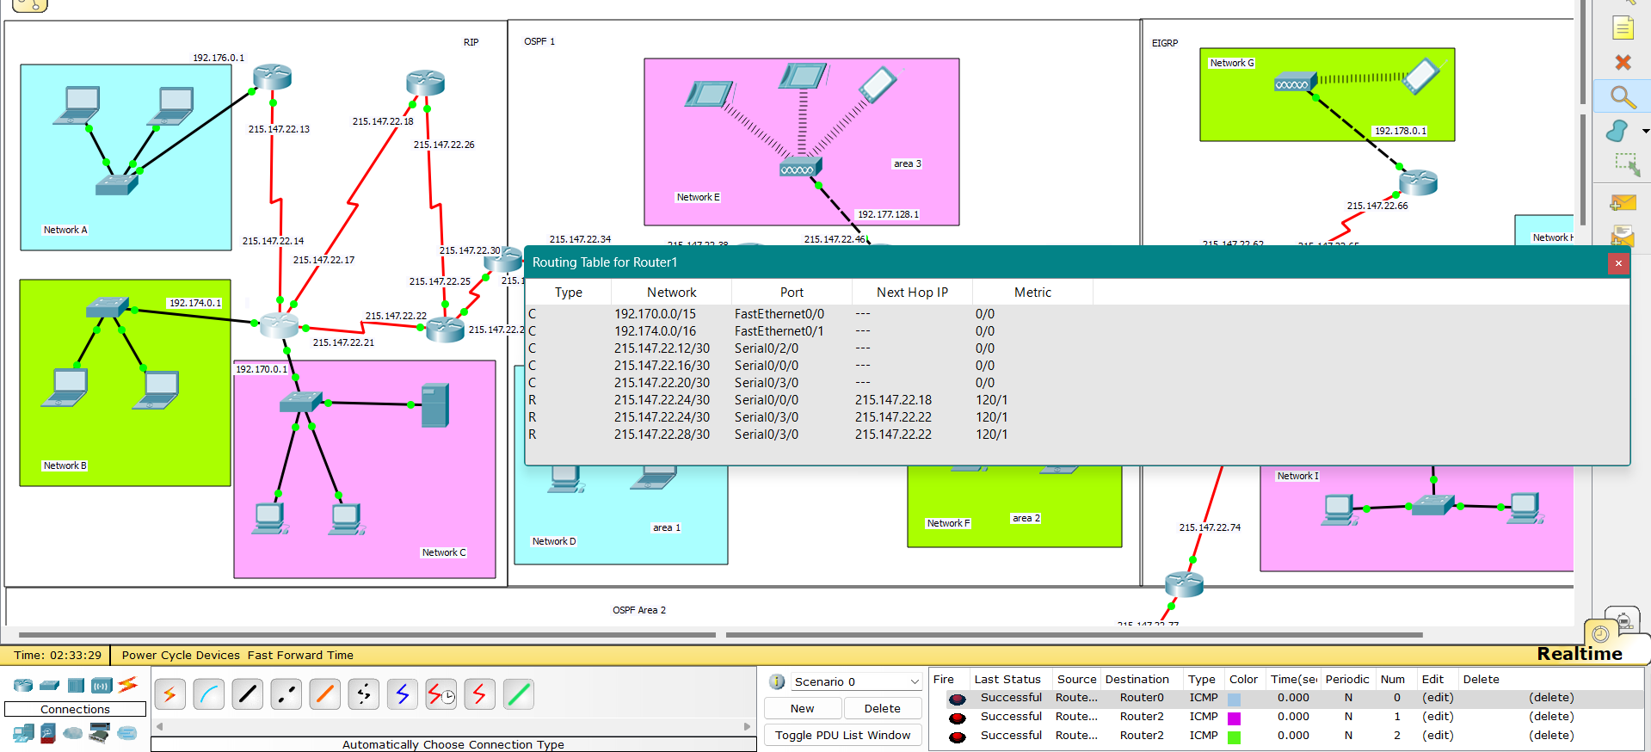

**Router 2**

**Routing Table**

**Router 3**

**Routing Table**

**Packet Transfer**

**RIP and OSPF 1**

**Router 4**

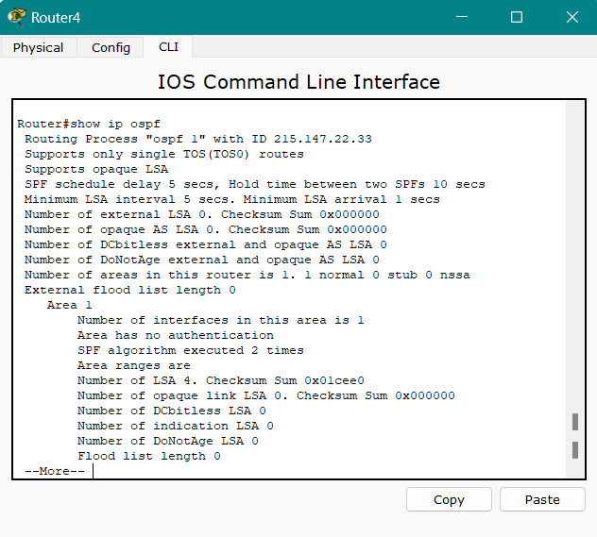

**Redistribution**

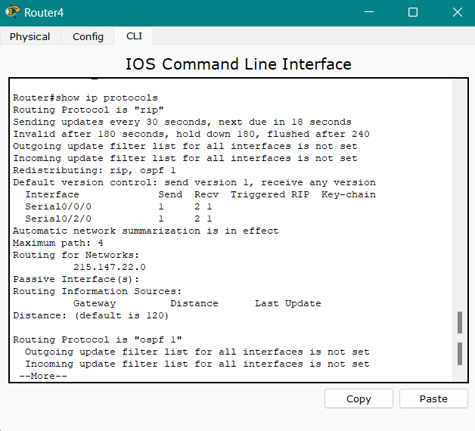

**OSPF 1**

**Router 5**

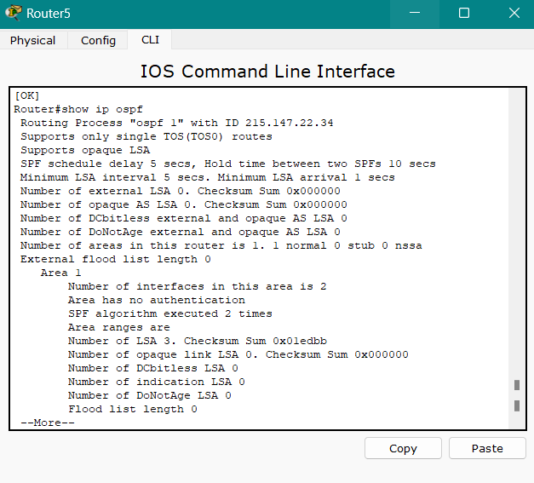

**Routing Table**

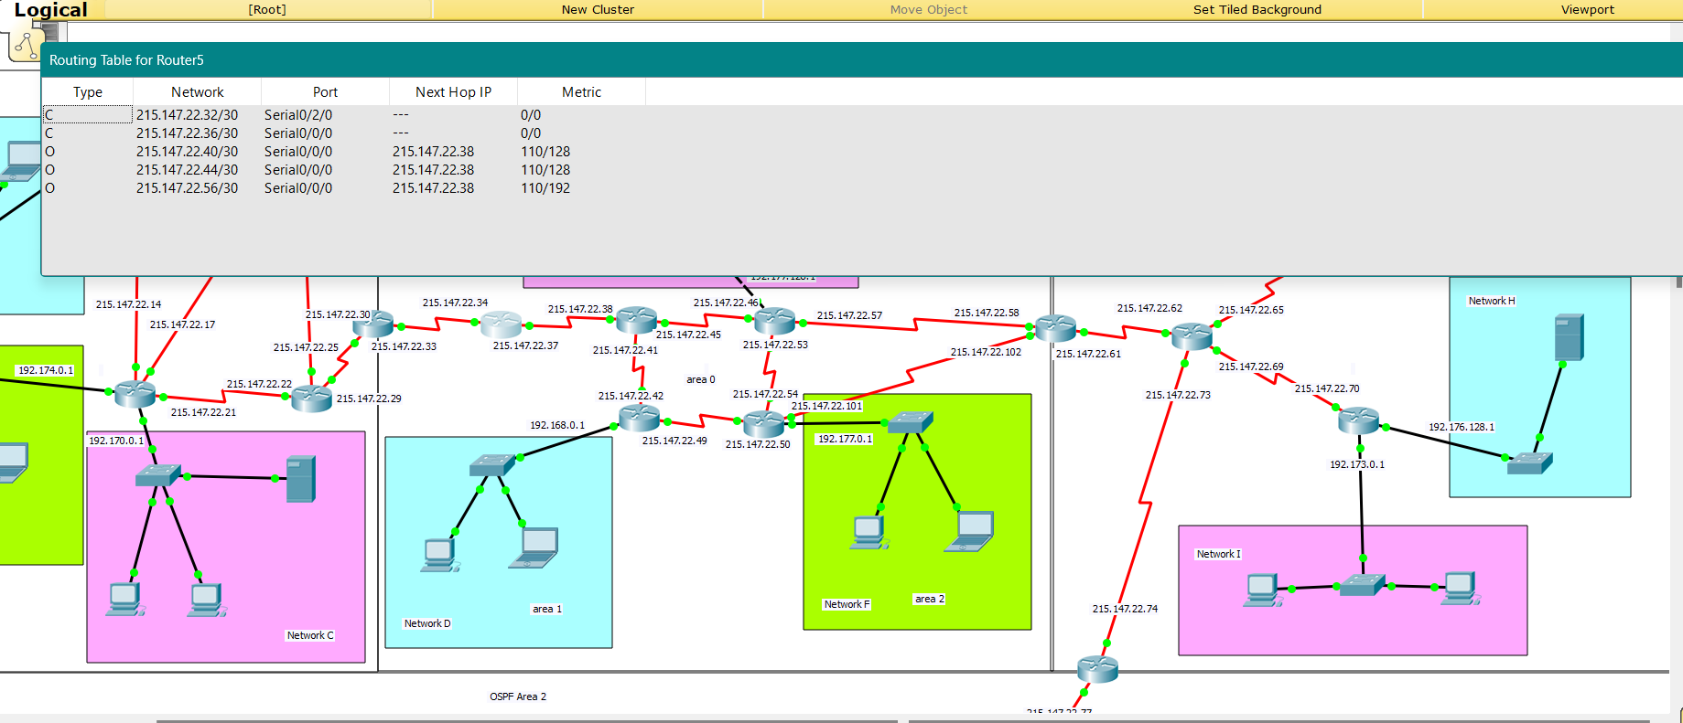

**Router 6**

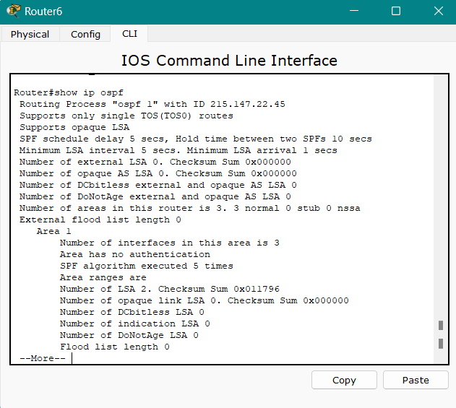

**Router 9**

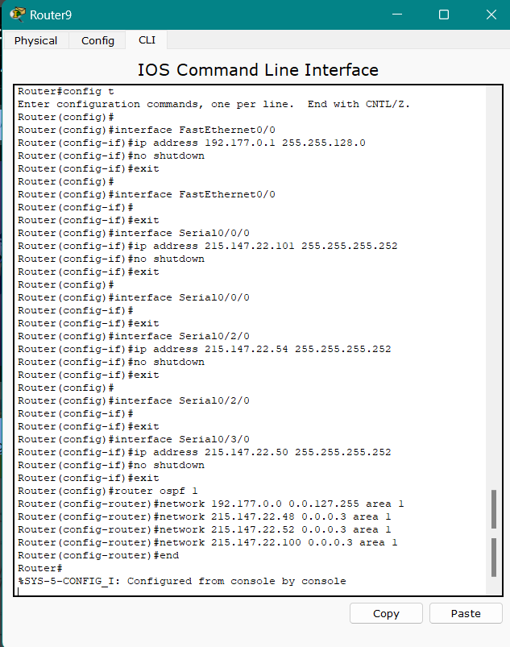

**Packet Transfer**

**OSPF 1 and EIGRP**

**Router 10**

**Redistribution**

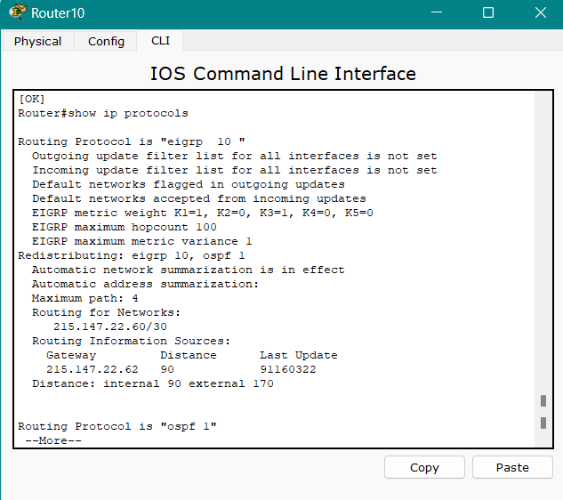

**Packet Transfer**

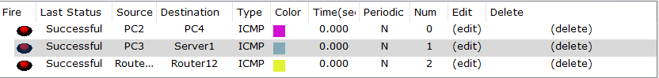

**EIGRP**

**Router 11**

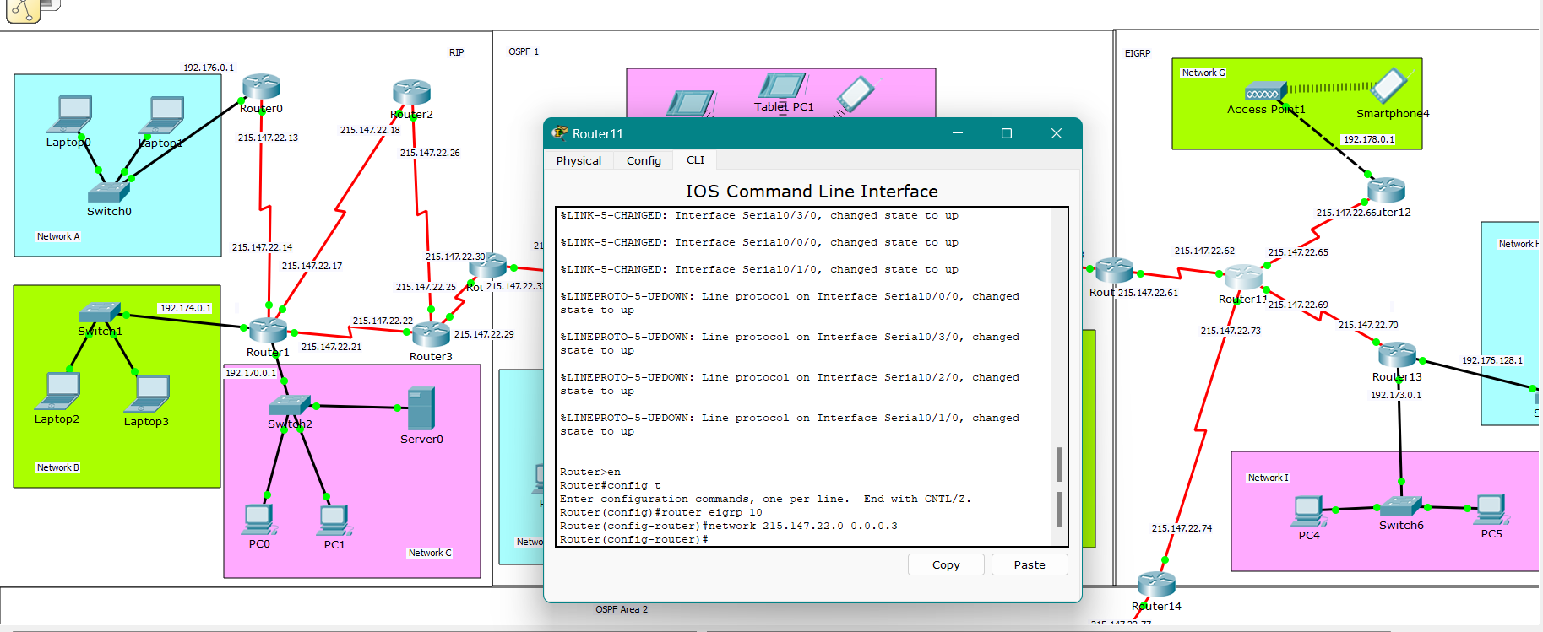

**Routing Table**

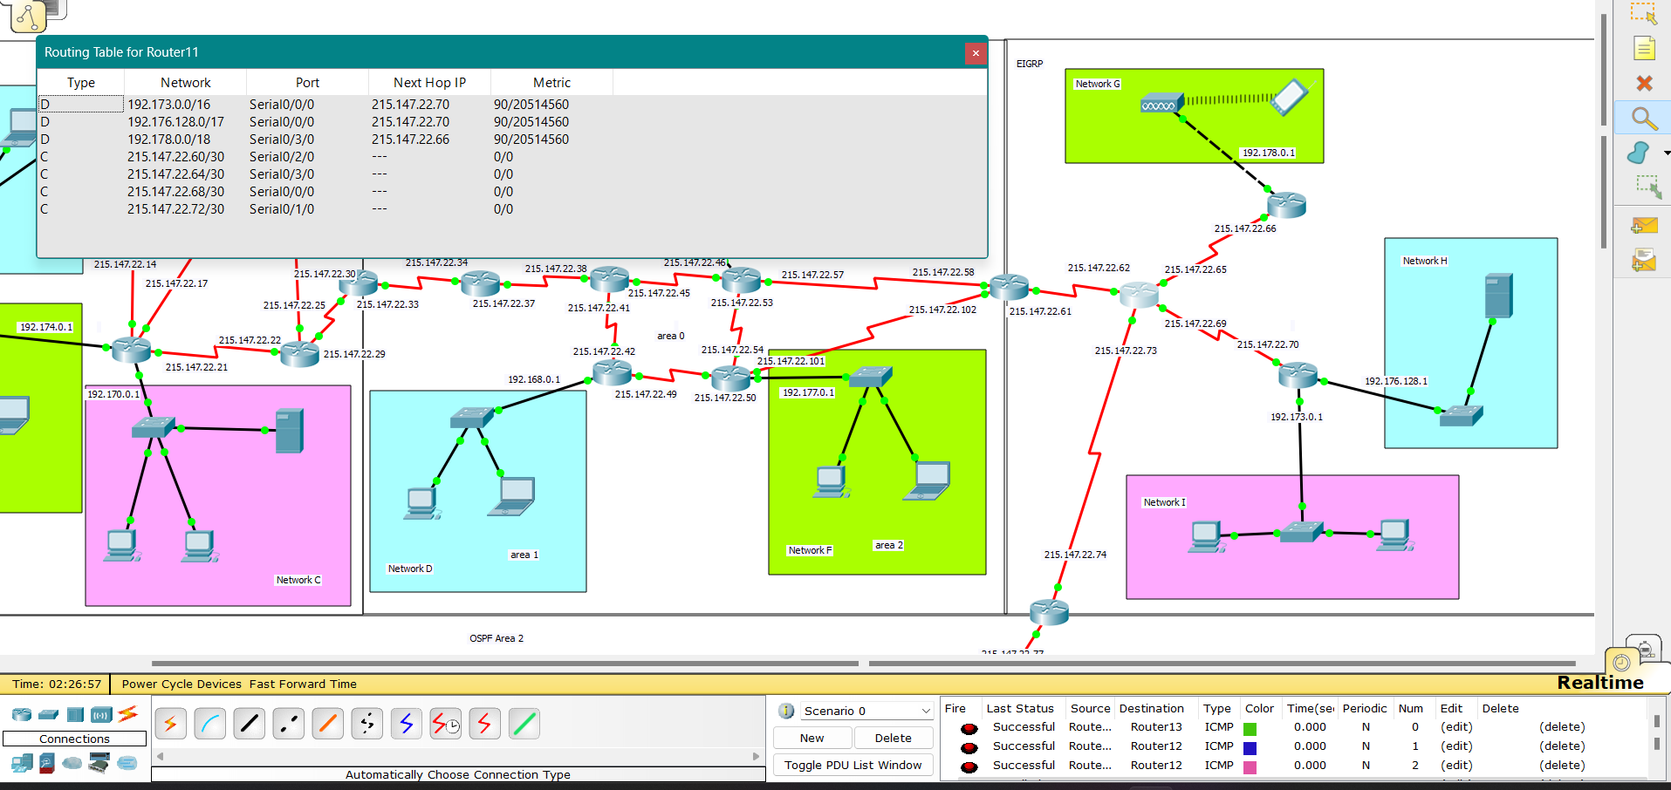

**Router 12**

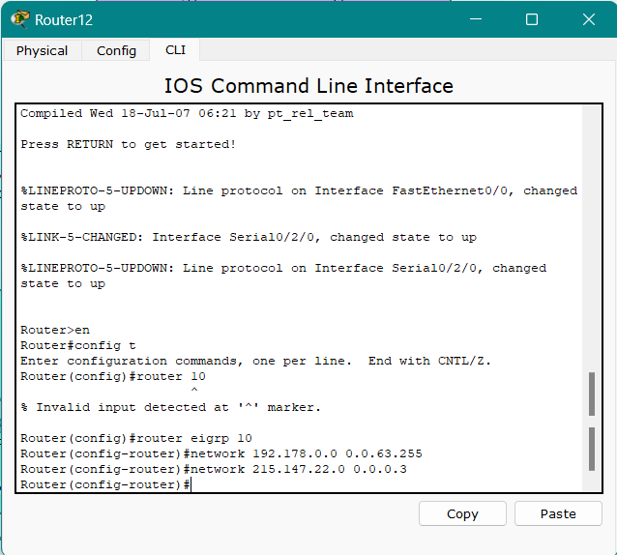

**Routing Table**

**Router 13**

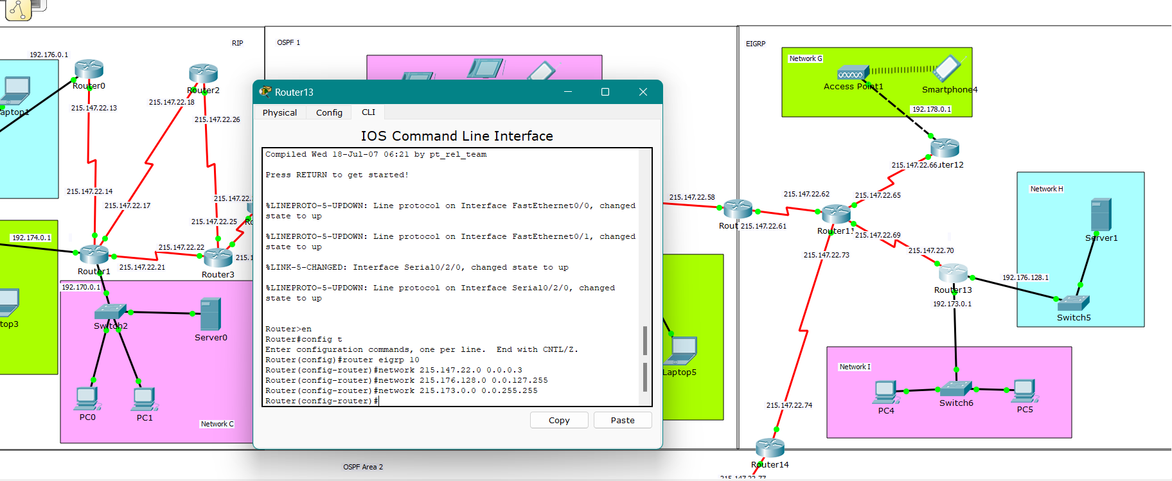

**Routing Table**

**Packet Transfer**

**EIGRP and OSPF**

**Router 14**

**Redistribution**

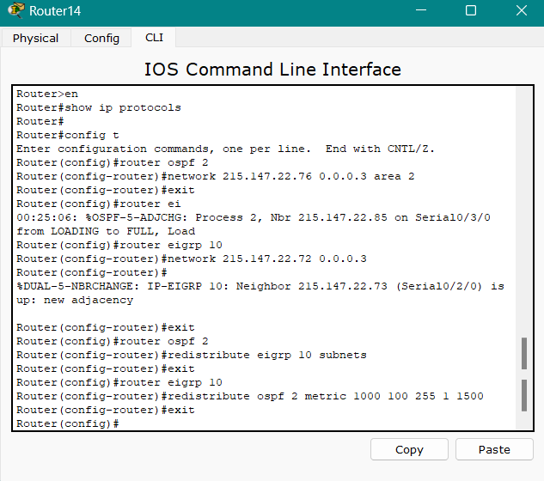

**Packet Transfer**

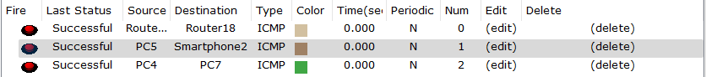

**OSPF 2**

**Router 15**

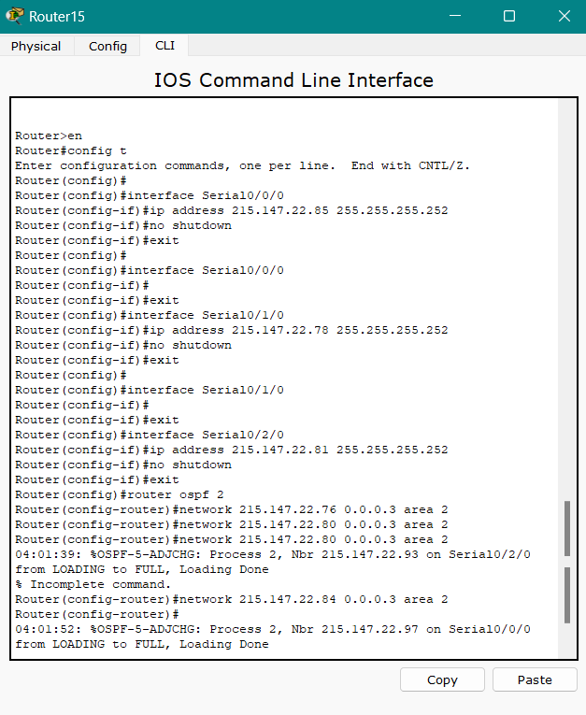

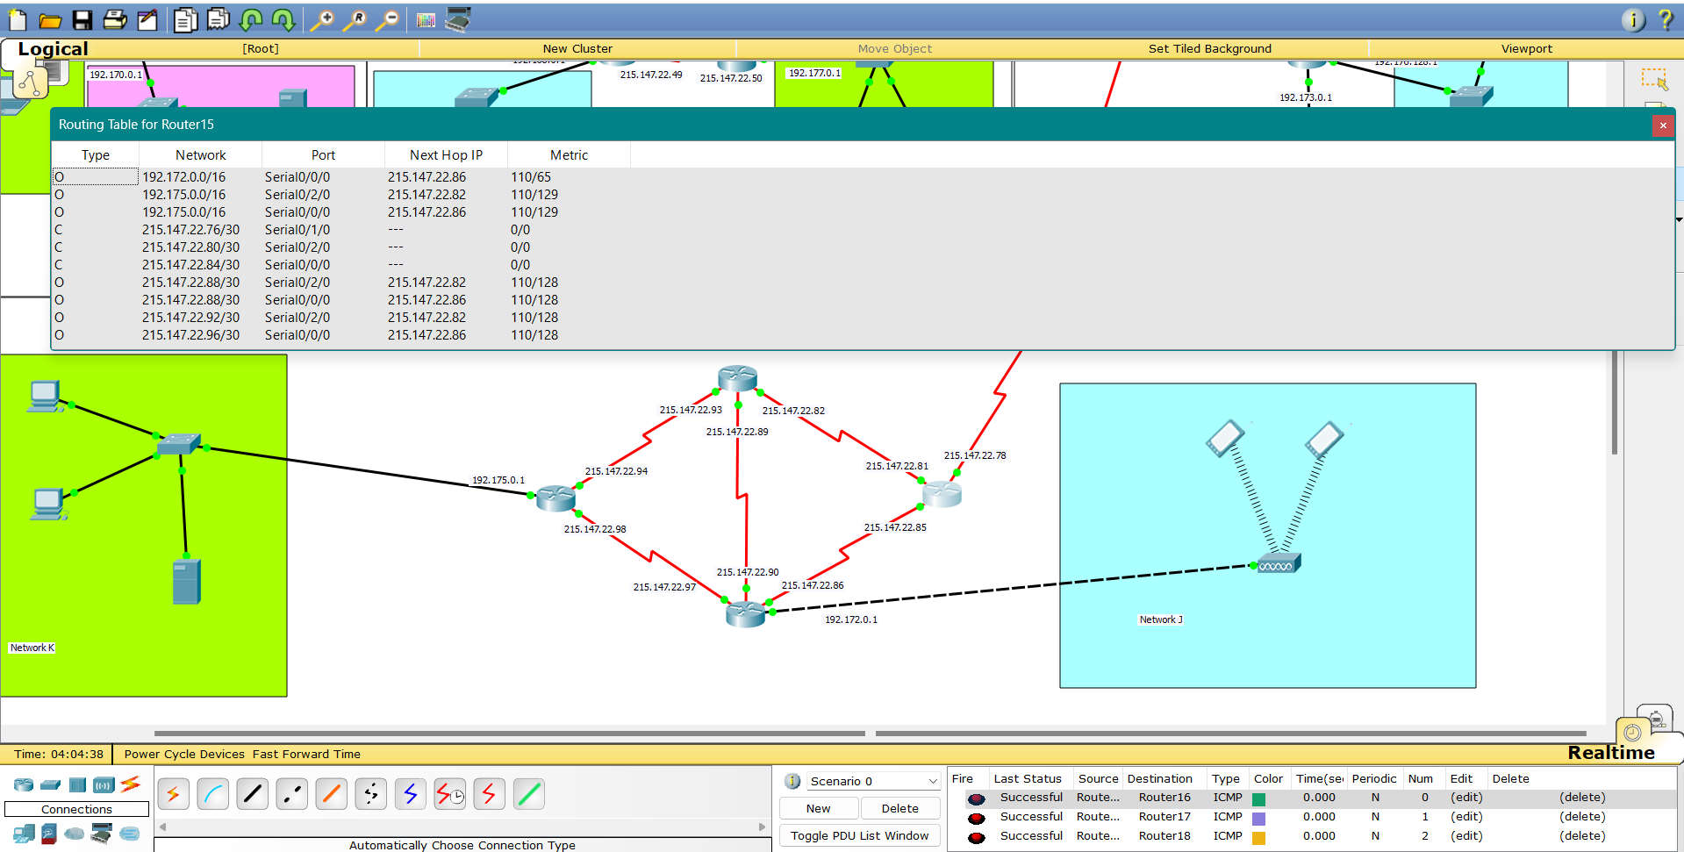

**Router 16**

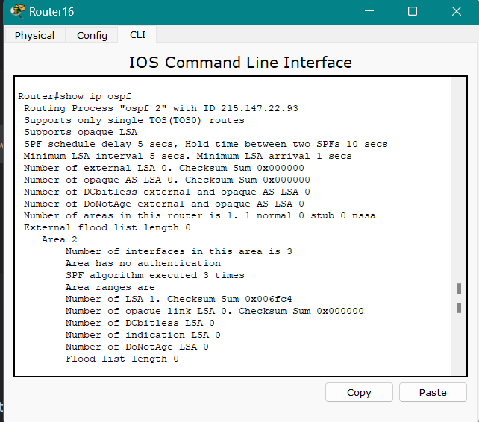

**Router 17**

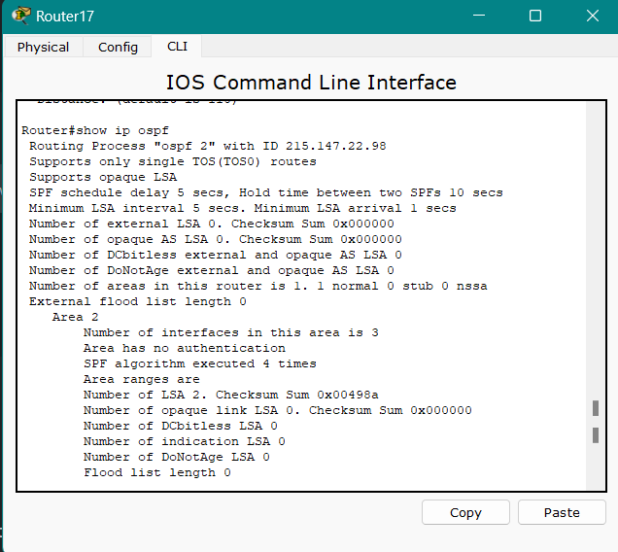

**Routing Table**

**Router 18**

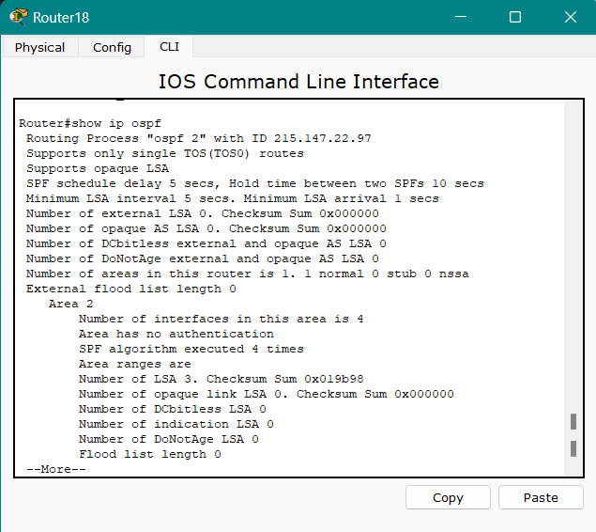

**Packet Transfer**

**SMTP**

Mail sent from pc1 to pc 0

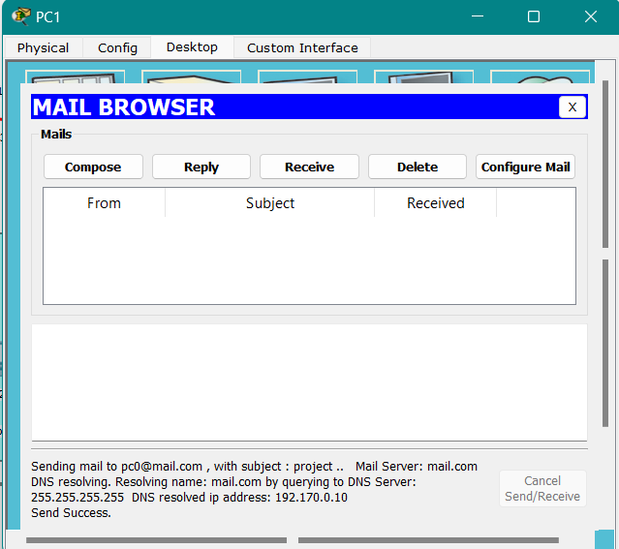

The mail received at pc0

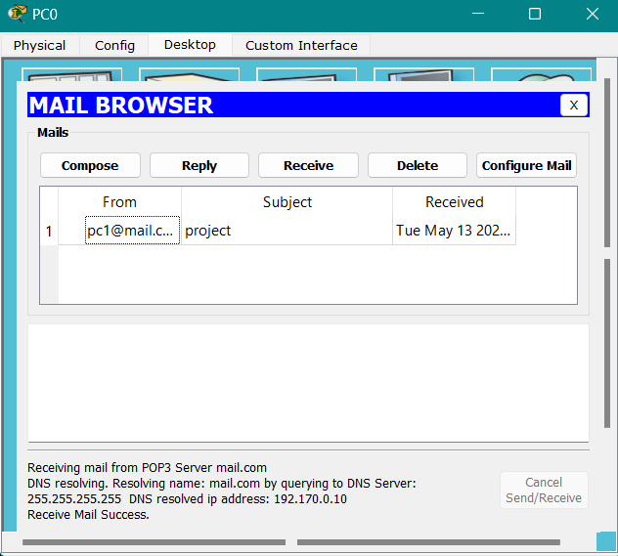

**DHCP**

**Network E**

**Network F**

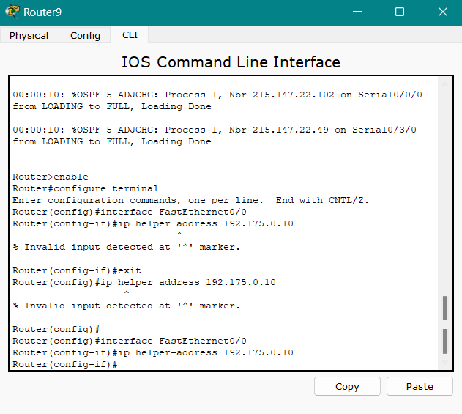

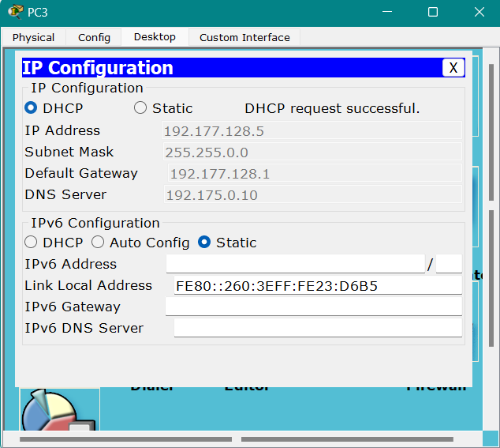

**Network G**

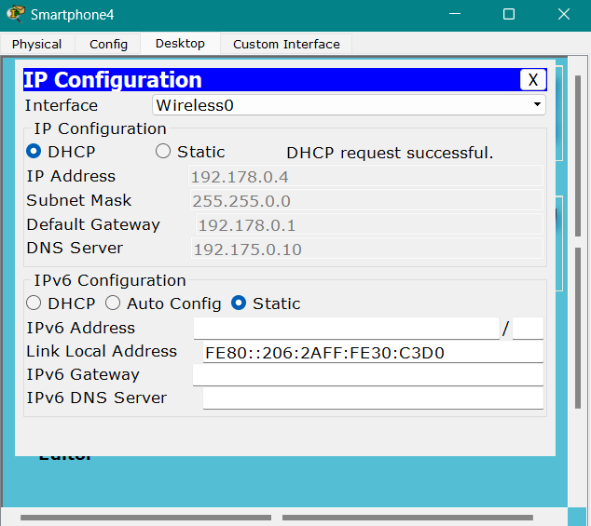

**Network I**

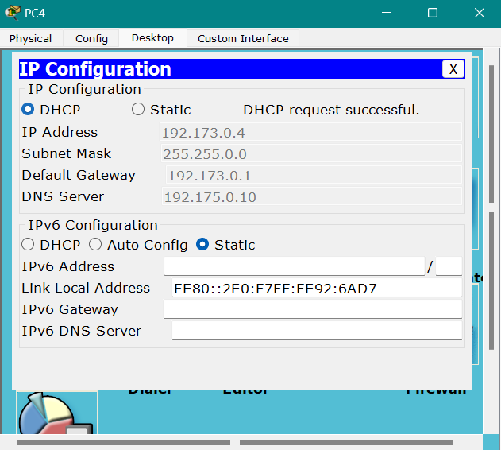

**Network J**

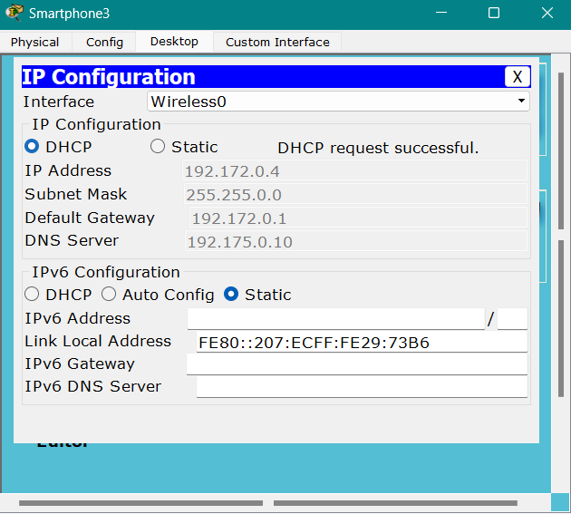

**Network K**

**NAT**

**Network E**

Static NATing with tablet 192.177.128.4

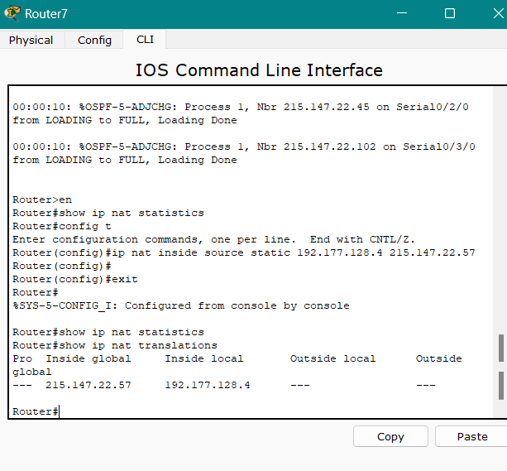

**Network J**

Static NATing with smartphone 192.172.0.2

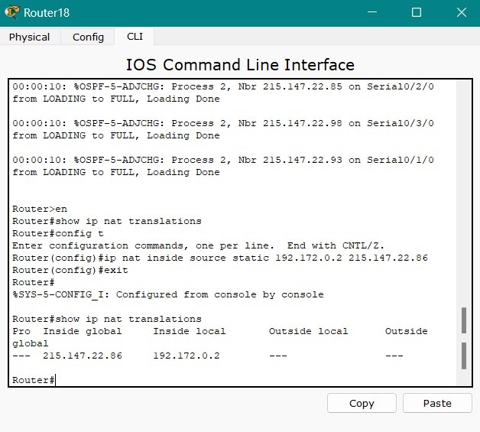

**ACL**

Packet transfer before ACL

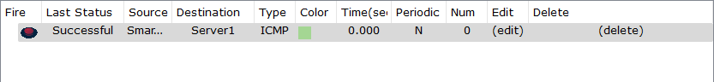

**Applying ACL**

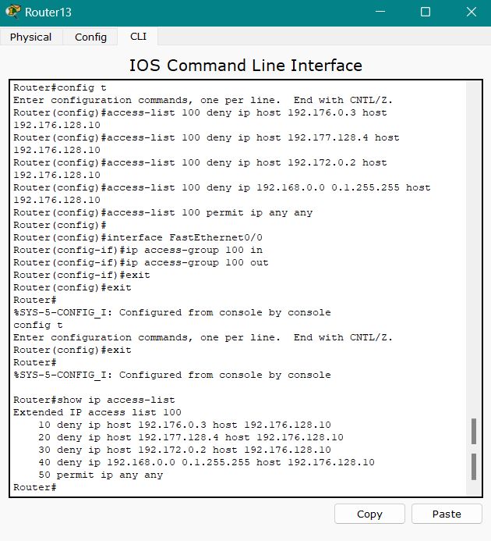

Packet transfer before ACL

